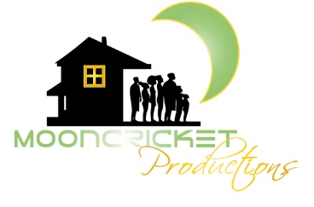AMUSE-BOUCHE COMEDY FESTIVAL
WHEN: June 26, 2021 5-10:30pm
WHERE: Allways Lounge 2240 St Claude Ave, New Orleans, LA 70117
SCHEDULE OVERVIEW:
5:00pm Doors Open

5:15-6:30 Improv Show: 2 Adult Women, Cast of Swamp Thing, No Lye Improv, Black Improv Alliance
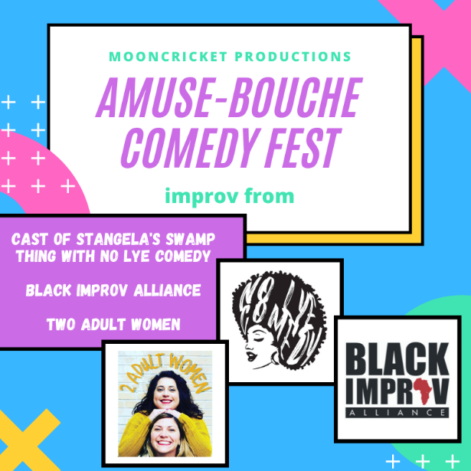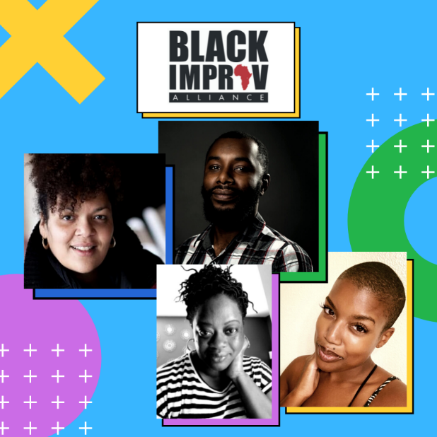

6:30-6:40 Live Trailer: Stangela’s Swamp Thing

7:00-7:45 Not Another Black Show
7:50-8:20 Mommylogeauxs

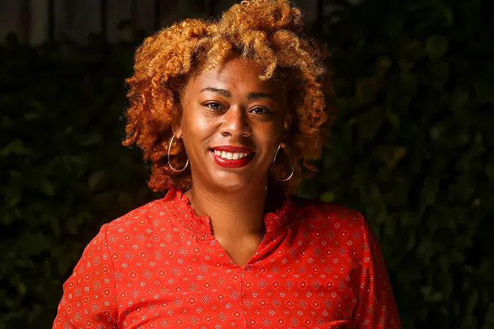
8:25-8:55 Two Adult Women
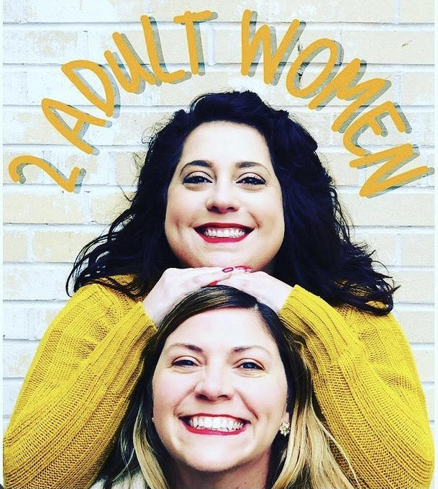

9:00-9:10 Live Trailer: Stangela’s Swamp Thing

9:10-10:30pm Standup Show
